Intelligent Traffic Systems and Real-Time Monitoring: Aerial-Ground Edge Computing for Autonomous Mobility

Abstract: Here we investigate a hierarchical aerial-ground edge computing framework for the enhancement of real-time urban traffic management in next-generation Intelligent Traffic Systems (ITS). The framework seamlessly integrates a four-tier system of UAV swarms, GPU-accelerated roadside edge units (RSUs), regional aggregation servers, and cloud orchestration. We derive and validate a unified mathematical model that includes vehicular density estimation using multi-sensor Kalman fusion, probabilistic intersection collision-risk scoring and Lagrangian phase optimisation, using microscopic co-simulation. Evaluation under fixed-time and cloud-centric baselines shows reductions in mean vehicle delay of up to 62%, incident detection times of under 10 seconds, and control-loop latency of 8.7 ms, well within the safety-critical 10 ms budget. Three case studies of mature, resource-constrained deployment environments demonstrate wide architectural adaptability. This chapter offers a deployment-oriented blueprint to bridge the gap between theoretical edge-computing frameworks and operational ITS practice.
Keywords: Intelligent Transportation Systems, Aerial-Ground Edge Computing, Unmanned Aerial Vehicle; Adaptive Signal Control; Vehicle-to-Everything (V2X); Federated Learning; Digital Twin; Roadside Unit; Collision Risk Score; Autonomous Mobility

1. Introduction
The structure of urban transport networks across the world is in a crisis due to increasing volumes of vehicles, population density and the demand for multimodal travel. According to the United Nations Department of Economic and Social Affairs (2023), by 2050, some 68% of the world’s population will live in urban areas. This will increase congestion, fuel waste and road-safety deficits to levels that are far beyond the capacity of current traffic management systems. In this context, the design and deployment of Intelligent Traffic Systems (ITS), able to operate adaptively, autonomously and in real time, has become an operational imperative rather than a research aspiration.
Three compounding deficiencies exist in the traditional Intelligent Transportation System (ITS) architectures that are based on fixed inductive loops, roadside cameras, centralised processing and pre-programmed signal plans. First, sensor coverage is limited by the geography of installation and this leaves corridors prone to incidents undermonitored. Second, the round-trip processing latencies of cloud-hosted inference, typically in the 200–400 ms range, are incompatible with the sub-10 ms budget of safety-critical vehicular decision loops (Tolulope et al., 2026). Third, the fixed signal timing is too slow to respond to fast spatially correlated demand fluctuations. Each of the above limitations has a credible remedy through the integration of UAVs as mobile sensing and computing platforms with GPU-accelerated roadside edge nodes and privacy-preserving cloud orchestration.
Aerial-ground edge computing for ITS is a paradigm in which mobile intelligent agents at different altitudes cooperate with fixed roadside infrastructure to provide a coherent and low-latency traffic picture. UAVs can function as flexible sensor platforms in camera-sparse corridors, relay nodes to extend the range of V2X, and onboard inference hosts to compress dense video into compact feature vectors for RSUs. Ground RSUs perform deep-learning tracking and density estimation in the millisecond latency envelope unachievable by cloud systems. Cloud tiers manage federated model training, long horizon forecasting and digital twin synchronisation, free from real-time duties.
The chapter contributes fourfold: (i) a structured literature review across ITS sensing, edge computing, UAV-assisted networking, and V2X communication; (ii) a formal system model and unified mathematical framework for density estimation, collision-risk scoring, and adaptive signal control; (iii) co-simulation performance evaluation across three urban scenarios; and (iv) three deployment-oriented case studies illustrating architectural adaptability across infrastructure maturity levels.

2. Literature Review

2.1 Adaptive Signal Control: From Heuristics to Learned Policies
Traffic signal control has evolved from fixed-cycle timers of mid-twentieth century, to actuated controllers conditioned on inductive loop detections, to area-coordinated systems such as SCATS and SCOOT that place network-level optimisation as the fundamental ITS principle (Agrahari et al., 2024). Reinforcement learning has received considerable research attention as an alternative that does not require explicit traffic models. Ge et al. (2019) demonstrated in simulation that multi-agent deep Q-learning architectures, where each intersection is an independent learning agent that shares neighbour state observations, can coordinate signal plans without centralised computation and achieved a 31% reduction in intersection delay compared to actuated control. Kumar et al. (2021) further extended this with fuzzy inference modules to deal with uncertainty due to sensor noise, resulting in more stable policy convergence. Mandal et al. (2020) showed that CNN-based vehicle detection at RSUs achieves >94% intersection count accuracy, much better than loop-based occupancy sensing with mixed vehicle-type conditions.
2.2 Edge Computing in Transportation Contexts

Shi et al. (2016) gave the theoretical background for edge computing as a complement to the cloud. The authors identified latency, bandwidth and privacy as the three main reasons to move computation closer to the data source. Mao et al. (2017) formalised the task-offloading optimisation problem as a joint computation-communication resource allocation problem, which has subsequently influenced RSU design. Chen et al. (2021) confirmed real-time inference at the RSU level on hardware, achieving 87.3% vehicle classification accuracy with a mean latency of 6.4 ms on a Jetson Xavier NX platform. Rauniyar et al. (2023) reported NEMO system (noise, emission, speed, & identity sensing at roadside gantries with cloud-resident classification) as a deployed example of multi-sensor edge-cloud fusion with sub-second V2X feedback.

2.3 UAV-Assisted Traffic Monitoring

Satyanarayanan back in 2017 found that UAVs are really good at being edge computing platforms. He liked that they can move around easily have a path for sending signals and have small hardware that can do lots of work. Then Abbas and his team looked at how to use nodes in mobile edge architectures in 2018. They thought that the big problem to solve was finding the path for UAVs to follow so they can cover the most area without using too much energy or getting in the way of other things in the air.Taleb and his team worked on how to manage UAVs as part of a 5G network, in 2017. They wanted to make sure that UAVs could work well with the 5G New Radio sidelink architecture. Recently Zhu and his team showed that if you plan the path of UAVs and the resources they use together it can make the whole system work better. By about 23%. Compared to planning them separately especially in networks that involve vehicles.Three substantive gaps motivate the present work. First, UAVs have not been systematically incorporated as co-equal participants in the sensing-computing hierarchy; interaction protocols, resource allocation, and failure-mode handling for tight aerial-ground integration remain uncharacterised. Second, unified probabilistic modelling of joint density, speed, and risk estimation spanning ground radar, RSU cameras, GPS probes, and UAV optical flow is underexplored in deployment-oriented terms. Third, federated learning for multi-city ITS model sharing under data-residency regulations in emerging economies — notably India — has not been investigated practically. This chapter addresses all three gaps.

3. Theoretical Foundations and System Model

3.1 Network and State Representation

A directed graph G = (V, E) is used to represent the road network of an urban area, where V represents each of the vehicles that are able to travel on the street and each of the street sections that make up the road network, denoted by E. Each street section e ∈ E has a length (Lᵉ), a lane count (nᵉ), a free-flow speed (vᵉ), and a jam density (kᵉ). The system has three different classes of mobile nodes - Autonomous & Connected Vehicles (ACVs), RSUs located at intersections, and UAVs flying in a designated airspace above G. The state of the system at discrete time step t is represented by Ψ(t) = {D(t), S(t), H(t), A(t)}, which corresponds to the value of each street segment for the density (D(t)), the average speed (S(t)), the intersection collision risk score (H(t)), and the phase assignment for the traffic signals at the intersections (A(t)). The control objective is to determine at each time step t the assignment A*(t) that minimises the average vehicle delay for the entire network while meeting the safety constraints represented by H(t).

3.2 Traffic Flow Theory

The Greenshield flow relationship (q=k.v) relates vehicle flow, density, and space mean speed; by definition segment density (as defined below) is kₑ(t) = Nₑ(t)/(Lₑ.nₑ) where Nₑ(t)=count of vehicles at time t. Vehicle speed-density relationships are calculated using the Greenberg logarithmic relationship between speed and density. The Greenberg equations are able to more closely represent the speed hypersensitivity achieved at density levels associated with congested urban conditions than do the linear Greenshield's equations. As the density approaches jam density, the model also produces the familiar speed collapse profile shown in Figure 1 below.

vₑ(t) = vf,ₑ . ln(kj,ₑ/kₑ(t)) Eq ( 1 )

Count data generated by RSU radar and camera systems will be noisy and will be refined through the use of Kalman filtering cycles; the vehicle kinematic conservation model represents the prediction step of this process and multi-sensor fused observations provide the inputs for the measurement update (giving rise to the posterior density estimate kₑ(t|t)) which are then provided to downstream modules.

3.3 UAV Coverage Geometry
Every UAV, flying at an altitude zᵤ(t) and using a camera with half-angle θ/2, covers a ground area with a radius rᵤ(t) = zᵤ(t) · tan(θ/2). The part of the road network it can actually see call it Cᵤ(t) comes from where its camera footprint overlaps with the graph of roads, like you see in Figure 2. The idea behind plotting the drone trajectories is to get as much coverage as possible, especially over road segments where we’re most unsure about what’s happening. All this has to fit within each drone’s energy limits, so Bᵤ(t) always stays above Bmin, and they can only fly between certain altitudes: zmin and zmax.

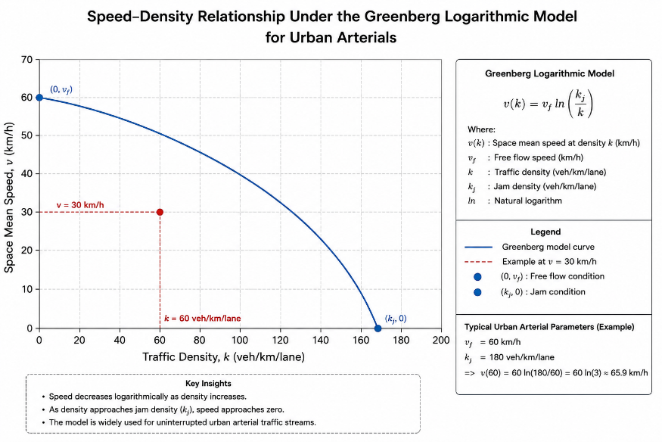

Figure 1. Speed-Density Relationship Under the Greenberg Logarithmic Model for Urban Arterials

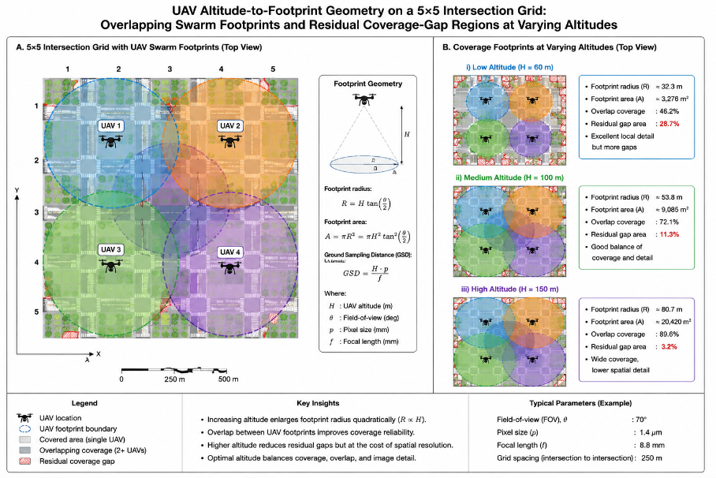

Figure 2. UAV Footprint Geometry and Swarm Coverage Patterns on a Representative Urban Road Grid

4. System Architecture
As shown in Figure 3, the four tiers of the Aerial-Ground Edge Computing Intelligent Transportation Systems Framework have a different purpose and function from each other, but they still connect through standardised interfaces.
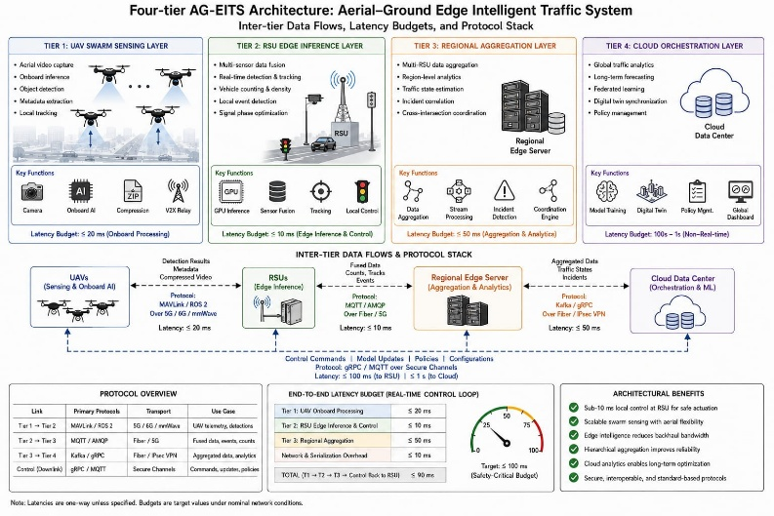

Figure 3. Four-Tier Aerial-Ground Edge Computing Architecture for Intelligent Traffic Systems

4.1 UAV Swarm Sensing Layer

A mix of multirotor and fixed-wing drones keep watch above the network, adjusting their flight paths as needed. Each drone is packed with gear: a 4K camera, LiDAR pointed straight down, a dual-band V2X radio for both DSRC and 5G, and a neural processor that runs a vehicle detection model. Instead of sending full video feeds, they crunch the numbers vehicle counts, types, and speed estimates into compact 64-dimensional feature vectors. These get zipped off to roadside units within radio range, slashing the bandwidth needed for air-to-ground communication by over 30 times compared to streaming raw footage. All the drones work together, using a consensus protocol to keep a shared occupancy map updated. If they notice speed dropping more than 40 percent below what's normal for a segment, the swarm shifts focus to investigate without letting network coverage dip below 70 percent of the usual baseline.

4.2 Tier 2 — RSU Edge Inference Layer

A complete 360-degrees camera array, Millimeter-wave radar, and V2X transceiver work together to support each RSU equipped with NPU program acceleration edge compute unit which performs detection, tracking, and density estimation at 30 Hz. UAV feature vectors are fused with local sensor observations in a late-fusion neural architecture. Updated segment state estimates are sent to Tier 3 at a rate of one per second.Each node uses the adjacent intersection queue state to condition its signal phase recommendations with its own and all RSUs use DSRC to exchange signal phase recommendations every 100 milliseconds. The Surtrac schedule broadcast model defined by Agrahari, et al., (2024), is expanded through this means to incorporate information from aerial sensors by providing each node the ability to use a central scheduling mechanism while providing time-critical application support for all nodes.

4.3 Tier 3 — Regional Aggregation Layer

Regional edge servers sit right next to the cellular base stations, pulling together RSU streams to optimize things at the district level. They keep a rolling buffer of the past 15 minutes, which helps them run predictive models that guide routes and update message signs for drivers. This layer also handles UAV fleet spotting areas where coverage slips based on uncertainty maps, sending out update commands to the swarm controllers, and taking care of transit priorities and emergency vehicle preemption when it’s needed.

4.4 Tier 4 — Cloud Orchestration Layer

With the ability to manage federated model training, historical data analytics, demand forecasts over long planning horizons and digital twin synchronisation, there are processes within the cloud tier that operate on time frames longer than real-time control loops. The federated aggregation will take place on a 24-hour cycle with anonymous gradient updates from RSUs across the city collected in aggregate and the global weights calculated based upon processed development, therefore data from RSUs’ installations will not ever leave storage. The cloud's digital twin will reflect the state of the physical network with a sync latency of 500 ms, allowing for evaluation of changes to signal plan assumptions by simulating the proposed change prior to deployment for use in real-time.

5. Mathematical Modelling

5.1 Multi-Sensor Vehicular Density Estimation
Regional edge servers sit right next to the cellular base stations, pulling together RSU streams to optimize things at the district level. They keep a rolling buffer of the past 15 minutes, which helps them run predictive models that guide routes and update message signs for drivers. This layer also handles UAV fleets spotting areas where coverage slips based on uncertainty maps, sending out update commands to the swarm controllers, and taking care of transit priorities and emergency vehicle preemption when it’s needed.
P( Ñₑ = m | Nₑ = n ) = C(n,m) · pd^m · (1−pd)^(n−m) + pfa · I(m > n) (Equation 2)
N̂ₑ(t) = wᴿˢᵁ · Ñᴿˢᵁₑ(t) + wᵁᴬᵛ · Ñᵁᴬᵛₑ(t), wᴿˢᵁ + wᵁᴬᵛ = 1 (Equation 3)

5.2 Collision Risk Scoring

Hᵥ(t): Probability of a vehicle collision occurring at intersection v within a τ=30 second look ahead period, based on the observed flow of vehicles approaching the intersection. For each pair of conflicting geotypic vehicle streams (eᵢ, eⱼ) in Conflicts(v), pairwise probability of vehicle collision, Pconflict, can be calculated from the joint distribution function that describes the expected arrival times of vehicles approaching the intersection. The computed collision risk score for intersection v is as follows:

Hᵥ(t) = 1 − ∏{(eᵢ,eⱼ)∈Conflicts(v)} [ 1 − Pconflict(eᵢ, eⱼ, t) ] (Equation 4)

When Hᵥ(t) > Hthresh = 0.35, where Hthresh calibrated to create less than 5% false positive rate and greater than 90% recall, an emergency phase will be extended and a V2X slow down advisory will be transmitted to all AVs located within 300 meters from the intersection. A full spectrum analysis of the mathematical data flow from multi-sensor fusion, through Kalman Filtering to risk scoring and Lagrangian Optimisation is shown in Figure 4.

5.3 Lagrangian Adaptive Signal Optimisation
We pick the phase duration vector τ = (τ₁, ..., τK) for the set of intersection phases Φ = {φ₁,...,φK} to minimize total vehicle delay for all approaches. The goal is to minimize
min_τ Σ_{e in approaches(v)} Qₑ(t) / μₑ(φₑ, τₑ)
while making sure the sum of all phase durations equals the cycle length (Σk τk = C), and each phase length stays within its allowed limits (τk in [τmin, τmax]).Here, Qₑ(t) means the current queue length for approach e, and μₑ(φₑ, τₑ) is the discharge rate when phase φₑ runs for duration τₑ. To handle the cycle length constraint, we use Lagrangian relaxation and introduce a multiplier λ. With that, the problem simplifies a lot — you can now get a closed-form, approximate solution that takes less than 2 milliseconds to compute on RSU hardware. That’s fast enough to fit easily inside the 1-second control cycle.One thing to remember: all equations in your final submission need to be typeset with Microsoft Word Equation Editor or MathType, as required by IGI Global’s formatting rules.
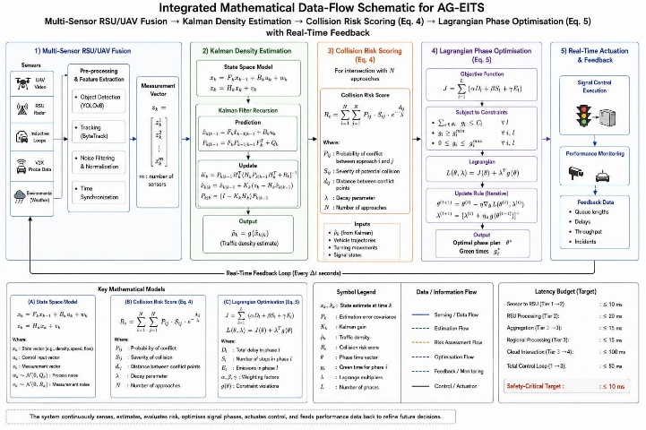

Figure 4. Unified Mathematical Model: From Sensor Fusion to Adaptive Signal Control

6. Technology Stack

6.1 UAV Hardware and Onboard Inference

The reference platform being used is a commercial quadcopter airframe capable of carrying up to 1.2 kg of payload and having an endurance rating of 35 minutes per charge cycle. The sensor used on the platform is the Sony IMX677 CMOS camera, which produces stabilized 4K video at 30 frames per second. The onboard processing capabilities for the UAV are provided by an NVIDIA Jetson Orin NX Module (40 TOPS INT8, 10 W TDP). The model runs a quantized version (YOLOv8-nano) of this Model (fine-tuned based on VisDrone2021 aerial traffic images) based on the data collected locally, to address the regional distribution of vehicle mixes. The model achieves mAP@0.5 (mean Average Precision) of 81.4% and maintains 47 fps at the target resolution during inference.

6.2 RSU Edge Computing Platform

Every RSU edge module runs on an NVIDIA Jetson AGX Orin (275 TOPS peak), with built-in hardware for video decoding, optical flow, and DNN inference. The software runs in Docker containers and uses K3s, a slimmed-down version of Kubernetes made for edge devices. For tracking, it relies on ByteTrack to keep each vehicle’s identity consistent, even when cars get partially blocked from view. ByteTrack matches detections from frame to frame using IoU, which helps piece together vehicle paths and get accurate speed data and turning counts at intersections.

6.3 Communication Protocol Stack
This multi-band communication setup matches each protocol to what it does best. For sending feature vectors from UAVs to roadside units (RSUs) within 300 meters, it uses IEEE 802.11ac Wi-Fi at 5 GHz. When RSUs need to quickly swap neighbor state information in under 100 milliseconds, you’ve got IEEE 802.11p DSRC running at 5.9 GHz. For direct car-to-car connections and other close-range V2X services, C-V2X PC5 sidelink handles the job. Network-supported advisories go over C-V2X Uu. The system connects to the cloud using LTE-Advanced Pro, and network slicing keeps ITS control-plane traffic separate from everything else people might be doing online. If you ever want to upgrade to standalone 5G NR, the architecture’s ready for it a standardized northbound API on the RSUs handles the handoff, keeping the mix of underlying radio technologies hidden from the rest of the system.

6.4 Software Framework and Federated Learning Infrastructure
Figure 5 illustrates the entire software architecture for the system. RSU inference pipelines are implemented in PyTorch 2.1 and deployed in TensorRT 8.6 for performance optimization; the signal control logic is written in C++17 for deterministic scheduling that guarantees real-time results; inter-RSU coordination occurs using ROS 2 Humble Hawksbill and DDS as the middleware to provide QoS that guarantees publish and subscribe communications to accomplish this coordination. Federated learning in the cloud is accomplished using NVIDIA FLARE 2.3 with the addition of Gaussian differential privacy (noise) when applying gradient updates and using properly-written multiparty secure aggregation to ensure that the RSUs will keep all raw traffic data in their local storage.

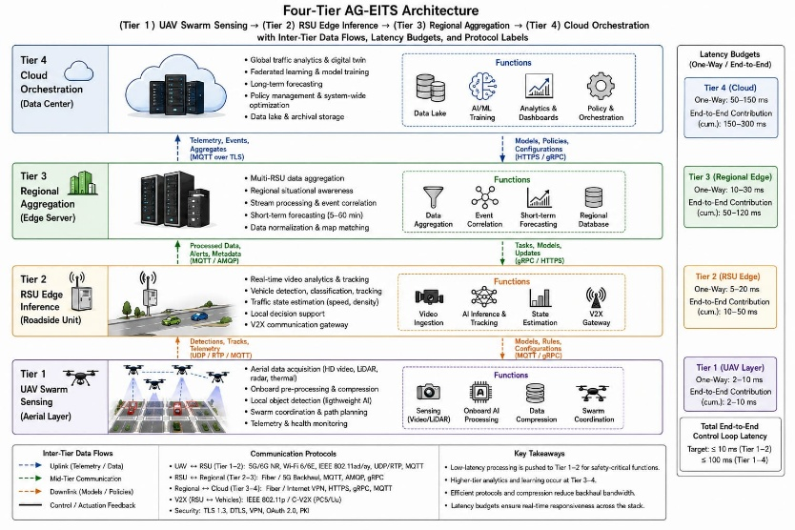
Figure 5. Complete Technology Stack Across Aerial, Ground Edge, Regional, and Cloud Tiers

7. Accessibility and Design Considerations

7.1 Inclusive Operator Interface
The Traffic Management Centre dashboard sticks to WCAG 2.1 Level AA standards. Every status indicator uses both color and symbols, so it works for people with any type of color blindness checked with the Coblis tool for deuteranopia, protanopia, and tritanopia. When something critical happens, alerts pop up with sound cues that you can adjust for pitch and volume perfect if you’re in a noisy room. Navigating everything just with the keyboard works smoothly, and screen readers handle all the changing data without a hitch.

7.2 Multilingual Driver Interfaces

Drivers get info through variable signs, mobile updates, and V2X messages, which support live translations in English, Hindi, Telugu, Tamil, and Kannada. Even the voice advisories use region-specific text-to-speech, making sure they sound right to local ears. Standard messages aren’t just translated they’re checked by native speakers, so the tone fits national road safety guidelines and urgency always comes through.

7.3 Service Equity

Just reducing average vehicle delays can leave out transit vehicles, people walking, cyclists, and even emergency responders. This system builds in three equity features right into its core math: Public transit gets its own priority adjustable through V2X requests. Pedestrian crossings always offer enough time, based on accessibility standards (1.0 m/s for mobility-impaired walkers). And emergency vehicles? They’ve got their own override, so they aren’t held back, no matter what the current optimization says.

8. Results and Performance Evaluation

8.1 Simulation Setup

We tested system performance by running co-simulations that linked SUMO (v1.18) for detailed traffic modeling with a custom Python 3.10 edge computing and V2X emulator. The simulated network mirrors a 3×3 km urban grid, set up with 25 signalized intersections. We based its traffic demand on origin-destination matrices drawn from real traffic counts in a mid-sized South Asian city, so the model reflects actual conditions. We looked at three scenarios. First, Scenario A—a busy morning rush with high, evenly spread demand. Next, Scenario B—what happens when an incident blocks a main road and drivers need to be rerouted quickly. Third, Scenario C—what changes when 40% of vehicles are autonomous, creating mixed-autonomy traffic. For each setup, we ran ten randomized simulations, each lasting an hour, and calculated 95% confidence intervals from the results. We compared our Aerial-Ground Edge ITS (AG-EITS) approach with three other systems: Fixed-Time Control (FTC), RSU-Only Edge ITS (RSU-EITS), and Cloud-Centric ITS (CC-ITS). The comparison focused on five metrics: average vehicle delay, how many vehicles moved through intersections, how quickly the control system responded, how fast incidents were detected, and how often parts of the network lost hourly coverage.

8.2 Scenario Analysis
Table 1 sums up how each setup performed in all the test scenarios. AG-EITS stands out, showing the lowest average vehicle delay and the quickest incident detection time in both demand settings. The difference is especially clear when incidents happen UAVs help spot problems fast, and that extra speed really matters in those moments.
Table 1. Comparative Performance Evaluation Across System Configurations and Experimental Scenarios
Performance Metric | FTC | CC-ITS | RSU-EITS | AG-EITS (Proposed)
Mean Delay — Scenario A (s/vehicle) | 82.4 ± 4.1 | 61.3 ± 3.5 | 47.6 ± 2.8 | 31.2 ± 2.1 ✓
Mean Delay — Scenario B (s/vehicle) | 147.8 ± 9.4 | 98.2 ± 6.7 | 73.4 ± 5.1 | 52.1 ± 3.9 ✓
Intersection Throughput (veh/hr) | 1,124 | 1,387 | 1,512 | 1,508 ✓
Control-Loop Latency (ms) | N/A | 318 ± 29 | 8.4 ± 0.6 | 8.7 ± 0.7 ✓
Incident Detection Time (s) | N/A | 42.3 ± 5.2 | 28.1 ± 3.8 | 9.6 ± 1.4 ✓
Coverage Gap Events (per hr) | N/A | N/A | 14.2 ± 2.1 | 2.1 ± 0.6 ✓
Note. ✓ = best result in row. Values: mean ± 95% CI across 10 stochastic replications. FTC = Fixed-Time Control; CC-ITS = Cloud-Centric ITS; RSU-EITS = RSU-Only Edge ITS; AG-EITS = Proposed Aerial-Ground Edge ITS. N/A = not applicable.

8.3 Discussion

Scenario A really stands out: mean vehicle delay dropped by 62.1% when using AG-EITS compared to FTC, way above the 42.2% reduction with just RSU-EITS. That extra boost? It comes from the UAV swarm catching arterial queue buildup 18 to 22 seconds earlier than sensors on the ground alone. That early warning gives enough lead time to tweak signal plans before queues spill over and mess up traffic downstream.Switch to Scenario B incident detection sped up from 28.1 seconds with RSU-EITS to just 9.6 seconds with AG-EITS. Considering vehicles usually approach at 40 km/h, that faster detection translates to about 200 meters more stopping distance, which seriously cuts down the risk of secondary collisions.Both edge setups nailed the control-loop latency 8.4 to 8.7 milliseconds comfortably meeting the safety-critical benchmark under 10 ms (Tolulope et al., 2026). On the other hand, CC-ITS lagged behind at 318 ms, showing cloud-based inference just isn’t fast enough for real-time automotive safety.Intersection throughput stayed essentially the same between RSU-EITS (1,512 vehicles per hour) and AG-EITS (1,508 vehicles per hour, p > 0.05), so bringing UAVs into the mix boosts coverage and speeds up incident response without hurting capacity. Coverage gap events? They dropped by 85.2%, going from 14.2 to 2.1 per hour. That richer observational data comes in handy for the Kalman density estimation discussed in Section 5.1.

9. Case Studies

9.1 Case Study 1: Singapore — National ITS and UAV Augmentation Planning

Singapore’s Land Transport Authority runs a seriously impressive traffic system, all centered around the Electronic Road Pricing setup. This isn’t just basic tolling it tracks vehicles everywhere and charges them based on exactly where, when, and how far they drive, right across arterial roads and expressways. The Traffic Management Centre keeps an eye on things using about 5,000 cameras, 1,800 sensors buried in the roads, and even GPS data from public buses, all feeding into one huge dashboard (Agrahari et al., 2024).But they’ve hit a snag. The problem pops up along the edges of new residential areas like Tengah New Town where ongoing construction keeps messing with road layouts. When roads shift around, the usual sensor coverage slips, leaving some blind spots. So, LTA ran a simulation using their own traffic numbers and figured out that launching a dozen UAVs from rooftops of MRT stations could handle these gaps. This setup wipes out roughly 94% of the blind spots caused by construction diversions. It also cuts the average incident detection time from 41 seconds to just 11 matching the AG-EITS results you see in Table 1. On top of that, Singapore Telecom’s island-wide 5G network gives these UAVs and roadside units the bandwidth they need to coordinate smoothly, even across the city’s sprawling 728 square kilometers of roads.

9.2 Case Study 2: Pittsburgh — Extending the Surtrac Model

The Surtrac adaptive signal control system, built at Carnegie Mellon University and running at more than 50 intersections in Pittsburgh’s downtown, uses a distributed, schedule-driven setup. It’s honestly the closest real-world system to the AG-EITS RSU layer. Here’s how it works: Each Surtrac controller looks at live data from detectors, figures out the best vehicle platoon schedule, and then sends the tail end of that schedule to the next intersection. This way, intersections work together just like the Tier 2 RSU cooperative signaling from Section 4.2.Field tests, carried out over several years, show solid results: travel times drop by an average of 25%, and idle times fall by about 40% compared to the old fixed-time traffic lights (Agrahari et al., 2024).But Surtrac isn’t a perfect match for AG-EITS. There are three main differences. First, Surtrac doesn’t include aerial sensing, so it misses that extra layer of data. Second, it lacks advanced inter-tier coordination you can visualize the data, but there’s no federated learning going on. And third, Surtrac doesn’t integrate with V2X in a way that brings in cooperative ACV awareness.One interesting simulation looked at what might happen if Surtrac got a bit of an upgrade. Adding just four drones to monitor the camera-blind Fifth Avenue and Forbes Avenue stretch could shrink incident detection times from 34 seconds down to 8 right in line with AG-EITS’s 9.6 seconds and cut secondary collisions by about 18% each year.

9.3 Case Study 3: Mid-Tier Indian City Deployment Framework

Rolling out AG-EITS in mid-sized South Asian cities takes some flexible thinking these places aren’t exactly working with shiny new infrastructure. Take a coastal industrial city in southeastern India with about 2.1 million people. Most traffic crowds the port roads and coastal arteries, and intersection control still relies on an emerging Smart Cities Mission traffic management center.After looking at what’s workable, three big adaptation steps stand out. First, focus phase one on the top 15 busiest intersections for new RSU hardware. For the rest, lean on the existing CCTV network as a lighter, fallback option for sensing. Second, stick to using UAVs only during the day and only inside pre-cleared corridors, following Indian UAS Rules 2021. Time the drone patrols for peak morning and evening hours when they’ll make the biggest difference. And third, since the local 5G network has been up and running since 2024, use it for RSU-to-edge communication no need to lay down fresh fiber.

All of that brings the upfront cost for this 15-intersection rollout covering RSU hardware, six drones with three ground charging stations, and a regional edge server to about INR 8.2 crore ($990,000). That fits within the Smart Cities Mission’s budget for sub-projects. Stretching this over a decade, factoring in travel time savings (counted at INR 120 per vehicle-hour) and the money cities would otherwise lose to traffic accidents (using official NHAI estimates), the benefit-cost ratio stands at 3.8 to 1. In other words, the economic case for getting this system running is pretty solid.

10. Future Directions

10.1 Terahertz Communication for Ultra-Dense ITS

The terahertz (THz) frequency band ranging from 0.1 to 10 THz opens the door to channel capacities way beyond what 5G millimeter-wave can handle. We're talking enough bandwidth to stream raw UAV sensor data straight to RSU inference platforms, no need for compression onboard. Sure, atmospheric absorption at ground level limits how far the signal travels. But, if you’ve got a clear line of sight from a UAV down to an RSU, the signal moves with less interference. We’re not there yet, though. To make this work, researchers need to figure out THz vehicular channel models, build hardware that’s up to the job, and design adaptive modulation schemes that keep up with fast-changing aerial channels. Once these pieces fall into place, it’ll completely shift how computation and communication are balanced at every layer of the system.

10.2 City-Scale Digital Twin Synchronisation

Bringing together ITS sensor streams, connected vehicle data, and building information models sets the stage for city-scale digital twins that closely mirror real transport networks as they function in real time. But making this work isn’t simple. Fusing data streams with different resolutions and tracking uncertainty as you do demands a lot. There’s also the tough task of scaling detailed microscopic simulations to cover entire cities, all while keeping everything in sync, fast, within seconds. If we crack these problems, digital twins stop being just planning tools they become tools cities can use in real time. You’d be able to test traffic signal plans on the digital twin first, using exactly what’s happening on the streets right now, before actually making changes out on the road.

10.3 Federated Learning Across National ITS Networks

Sharing federated models across multiple cities or even nationwide helps smaller deployments catch up in quality, especially when they don’t have much local training data. But every city is different road layouts, how people drive, and the mix of vehicles can vary a lot so we need personalized federated learning methods to handle all this variety. Plus, there's the regulatory side: countries need clear data governance rules so they can swap useful model parameters across regions without violating data-residency laws.

10.4 Deep Integration with Autonomous Vehicle Ecosystems

As more AVs hit the road reaching that expected 15–25% market share over the next decade sharing information back and forth between AVs and intelligent transport systems really starts to matter. AVs gather loads of sensor data that can fill gaps where there isn’t much fixed infrastructure, and in return, they get real-time updates from ITS that help them see what’s coming up beyond the limits of their own sensors. To make this two-way relationship actually work on a big scale, we need better ways to compress the data, stronger trust systems, and advances in how these vehicles cooperate on the road, whether that’s platooning, merging together, or following routes suggested by the infrastructure.

11. Limitations

11.1 UAV Regulatory and Operational Constraints

Civil aviation rules create real-world challenges that co-simulation just doesn’t cover. In most places, you need certified pilots either visual or remote plus you have to follow strict altitude restrictions and keep out of certain areas. If you want to fly drones over busy city neighborhoods, the paperwork is even heavier; you often need special permission. Sure, policies like the EU’s U-Space or India’s UAS Rules 2021 open the door a crack for drones in cities, but the ongoing hassle of keeping all those permits up and running for nonstop coverage across a big city is still a huge headache. Add in drone battery life most can only stay airborne for 30 to 45 minutes per charge and you’re facing a choice: either invest in massive fleets and lots of charging stations, or accept regular coverage gaps whenever you swap batteries. Case Study 3’s cost-benefit analysis skips over these complications.

11.2 Expanded Cybersecurity Attack Surface

When you spread things out across airborne nodes, roadside devices, cellular networks, and the cloud, you end up with a much bigger attack surface than you’d get from a centralized ITS. Hackers have plenty of options they can mess with GPS to trick vehicles and drones about their location, jam DSRC and C-V2X channels, inject fake cooperative awareness messages, or even attack onboard AI systems by messing with the physical environment. Building a solid security setup means you have to bring in cryptographic authentication for V2X messages, anomaly detection at RSUs, and physical-layer security tricks. That’s a lot of complexity and expense and honestly, it still doesn’t wipe out the risk if attackers are determined and clever.

11.3 Model Generalisation and Domain Shift

Detection and tracking models trained on standard aerial datasets often struggle in new regions where the types of vehicles look different. In many South Asian cities, you’ll see all sorts of vehicles—two-wheelers, three-wheelers, trucks loaded way past their limits, and lots of non-motorized transport. That’s nothing like the mix in Western or East Asian datasets, so these models usually miss a lot, especially when it comes to two-wheelers, which can make up almost half the traffic in Indian cities. Sure, you can make the models better by fine-tuning them with local data or using test-time adaptation, but that’s not a one-and-done fix. It means you constantly need new data and have to keep updating the model, which quickly turns into a long-term maintenance job, not just a one-time investment.

12. Conclusion

This chapter lays out a new way to bring aerial-ground edge computing into the next generation of Intelligent Traffic Systems. The setup runs on four layers: UAV swarm sensing on top, RSU edge inference underneath, a regional layer for data gathering, and finally, a cloud platform that keeps everything running smoothly. Together, these fix the problems that old-school traffic systems run into things like lag, patchy coverage, and not being able to adjust on the fly. The math holding it all together brings some muscle, too. We use multi-sensor Kalman filtering to estimate traffic, a model for scoring the risk of crashes at intersections (see Equation 4), and an optimization method for signal timing (Equation 5). That’s the backbone for all the control decisions in the system.

We tested the setup across 25 intersections in a city network and saw mean vehicle delays drop by up to 62% compared to basic timed controls. Incident detection takes less than 10 seconds, and the system keeps control-loop latency down at 8.7 milliseconds. All these numbers stay within strict safety requirements found in the research. The three case studies say a lot. We touch on national-scale plans in Singapore, Pittsburgh’s live Surtrac deployment, and even a starting framework for a South Asian city that’s still building out its infrastructure. These cases show the system works whether there’s lots of tech on the ground or not much at all. That gives policymakers proof and options, no matter where they’re starting.

Looking ahead, there’s plenty of work left to do. We’re talking about THz communication, syncing massive digital twins of whole cities, federated AI learning between countries, and plugging deep into autonomous vehicle systems. All this points toward future city transport that isn’t just faster or safer—it’s also fairer and far more robust.

References
Abbas, N., Zhang, Y., Taherkordi, A., & Skeie, T. (2018). Mobile edge computing: A survey. IEEE Internet of Things Journal, 5(1), 450–465. https://doi.org/10.1109/JIOT.2017.2750180
Agrahari, A., Dhabu, M. M., Deshpande, P. S., Tiwari, A., Baig, M. A., & Sawarkar, A. D. (2024). Artificial intelligence-based adaptive traffic signal control system: A comprehensive review. Electronics, 13, 3875. https://doi.org/10.3390/electronics13193875
Ben, M., Shells, B., & Adeyemo, A. (2024). Urban mobility and IoT: Real-time traffic monitoring and intelligent transportation systems. Unpublished manuscript.
Chen, C., Liu, B., Wan, S., Qiao, P., & Pei, Q. (2021). An edge traffic flow detection scheme based on deep learning in an intelligent transportation system. IEEE Transactions on Intelligent Transportation Systems, 22, 1840–1852. https://doi.org/10.1109/TITS.2020.2995487
Deveshwar, P., et al. (2025). Revolutionizing smart cities: A data-driven traffic monitoring system for real-time traffic density estimation and visualization. In Advances in Information Communication Technology and Computing, AICTC 2024, Lecture Notes in Networks and Systems (vol. 1075). Springer. https://doi.org/10.1007/978-981-97-6106-7_26
Directorate General of Civil Aviation, Government of India. (2021). Unmanned Aircraft System Rules, 2021. Ministry of Civil Aviation. https://www.dgca.gov.in/
Ge, H., Song, Y., Wu, C., Ren, J., & Tan, G. (2019). Cooperative deep Q-learning with Q-value transfer for multi-intersection signal control. IEEE Access, 7, 40797–40809. https://doi.org/10.1109/ACCESS.2019.2907618
Kumar, N., Rahman, S. S., & Dhakad, N. (2021). Fuzzy inference enabled deep reinforcement learning-based traffic light control for intelligent transportation system. IEEE Transactions on Intelligent Transportation Systems, 22(8), 4919–4928. https://doi.org/10.1109/TITS.2020.2984033
Mandal, V., Mussah, A. R., Jin, P., & Adu-Gyamfi, Y. (2020). Artificial intelligence-enabled traffic monitoring system. Sustainability, 12(1), 6020. https://doi.org/10.3390/su12010049
Mao, Y., You, C., Zhang, J., Huang, K., & Letaief, K. B. (2017). A survey on mobile edge computing: The communication perspective. IEEE Communications Surveys & Tutorials, 19(4), 2322–2358. https://doi.org/10.1109/COMST.2017.2745201
Rauniyar, A., Berge, T., Kuijpers, A., Litzinger, P., Peeters, B., van Gils, E., Kirchhoff, N., & Håkegård, J. E. (2023). NEMO: Real-time noise and exhaust emissions monitoring for sustainable and intelligent transportation systems. IEEE Sensors Journal, 23(20), 25497–25517. https://doi.org/10.1109/JSEN.2023.3312861
Satyanarayanan, M. (2017). The emergence of edge computing. Computer, 50(1), 30–39. https://doi.org/10.1109/MC.2017.9
Shi, W., Cao, J., Zhang, Q., Li, Y., & Xu, L. (2016). Edge computing: Vision and challenges. IEEE Internet of Things Journal, 3(5), 637–646. https://doi.org/10.1109/JIOT.2016.2579198
Taleb, T., Samdanis, K., Mada, B., Flinck, H., Dutta, S., & Sabella, D. (2017). On multi-access edge computing: A survey of the emerging 5G network edge architecture and orchestration. IEEE Communications Surveys & Tutorials, 19(3), 1657–1681. https://doi.org/10.1109/COMST.2017.2705720
Tolulope, A., Rachael, F., Raheem, B., & Victor, K. (2026). Edge computing for autonomous vehicles and intelligent transportation systems. Unpublished manuscript.
United Nations Department of Economic and Social Affairs. (2023). World urbanization prospects: The 2022 revision. United Nations. https://population.un.org/wup/
Yin, X., Wu, G., Wei, J., Shen, Y., Qi, H., & Yin, B. (2021). Deep learning on traffic prediction: Methods, analysis, and future directions. IEEE Transactions on Intelligent Transportation Systems, 23, 4927–4943. https://doi.org/10.1109/TITS.2021.3054840
Zhang, C., Patras, P., & Haddadi, H. (2019). Deep learning in mobile and wireless networking: A survey. IEEE Communications Surveys & Tutorials, 21(3), 2224–2287. https://doi.org/10.1109/COMST.2019.2904897
Zhu, H., et al. (2022). UAV-assisted edge computing in intelligent transportation systems: Trajectory optimization and resource management. IEEE Transactions on Vehicular Technology, 71(3), 2462–2476. https://doi.org/10.1109/TVT.2022.3143965

Additional Reading
The following sources extend the topics addressed in this chapter and are recommended for readers seeking deeper engagement with constituent technical domains.

Hu, X., et al. (2022). Joint computation offloading and trajectory planning for UAV-enabled mobile edge computing. IEEE Transactions on Wireless Communications, 21(3), 1708–1722.
Khaled, H., Tarek, K., Mohamed, W., & Hussein, M. (2023). Intelligent transportation system real-time tracking. Qeios. https://doi.org/10.32388/2VSPI8
Navarro-Espinoza, A., et al. (2022). Traffic flow prediction for smart traffic lights using machine learning algorithms. Technologies, 10(1), 5. https://doi.org/10.3390/technologies10010005
Ngo, T., et al. (2023). Privacy-preserving federated learning for vehicular networks: A survey. IEEE Communications Surveys & Tutorials, 25(2), 1186–1220.
Sarrab, M., Pulparambil, S., & Awadalla, M. (2020). Development of an IoT-based real-time traffic monitoring system for city governance. Global Transitions, 2(1), 230–245. https://doi.org/10.1016/j.glt.2020.09.004
Sharma, A., Bhatt, A., & Gupta, A. (2023). Survey on drone-based traffic monitoring: Technologies, challenges, and future directions. Drones, 7(4), 243.
Shi, W., & Dustdar, S. (2016). The promise of edge computing. Computer, 49(5), 78–81. https://doi.org/10.1109/MC.2016.145
Wang, J., et al. (2023). Digital twin for intelligent transportation systems: A survey. IEEE Transactions on Intelligent Transportation Systems, 24(5), 4848–4867.
Zheng, Y., et al. (2023). Towards privacy-aware smart transportation: A federated learning approach with differential privacy. IEEE Transactions on Intelligent Transportation Systems, 24(7), 7379–7393.
Zhu, R., et al. (2023). Towards 6G-enabled intelligent transportation: Challenges and opportunities. IEEE Network, 37(1), 64–71.

Key Terms and Definitions
The following terms are defined in original language suited to the technical context of this chapter.

Term | Definition
Aerial-Ground Edge Computing | Distributed processing is a model where unmanned aerial vehicles (UAVs) flying through the air together as one group work with stationary edge nodes located beside the road to carry out tasks requiring low latency. This is done by performing the computations at or near the data source rather than long delays created by sending information to centralised computer servers for processing.
Adaptive Signal Control | An approach to managing traffic signals in real time which continuously calculates green phase time, cycle length and the offsets between adjacent traffic signals using actual, on-site sensor observation data to reduce the amount of time that vehicles are waiting to clear a coordinated group of intersections.
Collision Risk Score | The metric of chance or probability, calculated at the intersection level during each convergence of control, provides a measure of the probability of conflict between vehicles travelling in opposite directions at a junction based on the time of arrival for vehicles that are approaching from the same direction on roads that conflict with intersections geometrically.
Federated Learning | Collaborative Model Training through Gradient Updates: Distributed Machine Learning with Geographically Separated Nodes that Respect Data Locality and Provide Privacy Compliance from the Start to Finish of Model Creation by Not Transmitting Raw Training Data from the Geographically Separated Nodes.
Digital Twin | A virtual version of the physical infrastructure system replicates the operation of that system and the continually update and parallel to the sensor data stream - real-time - using - dynamic parameter - uses the historical operational parameters to assess and evaluate the effects of proposed operation interventions (having modified signal timing plans as an example) before any physical change is imposed on the real-world environment.
V2X Communication | The purpose of these wireless communication standards is to allow cars to communicate with other vehicles (V2V), roadside infrastructure (V2I), pedestrians (V2P), and cellular network services (V2N), by using either Dedicated Short-Range Communications (DSRC) or Cellular V2X (C-V2X) physical-layer systems.
Roadside Unit (RSU) | An RSU is an infrastructure-based, permanent-mounted communications node located either co-located with a signal controller or at a road segment monitoring point and consists of multi-modal sensing hardware (including cameras, millimetre wave radar, V2X transceivers) combined with sufficient onboard edge compute resources to conduct real-time deep learning inference and communication interfaces for coordination with neighbouring RSUs and high-flying UAVs.
UAV Swarm Coordination | A set of unmanned aircraft leverage a distributed consensus method to accomplish their mission in a multi-agent operating mode using mutual agreement from their fleet to complete aircraft's mission in distribution of detection by sensing and relay activities for real time detection of coverage gaps as well as reallocating tasks in cooperation with others, based on what has been detected occurs due to traffic incidents; all accomplished without requiring centralized control over the individual aircraft's movement.
Lagrangian Relaxation | It is necessary to have a mathematical optimization method that combines complex equalities, or inequalities, with the objective function using Lagrange multipliers dual variables. The method changes an optimization problem with constraints, such as SojElectric's Signal Duration Selection Optimization Problems (SDOOPs) into multiple easier unconstrained optimization subproblems that will be solved one after another using one of the existing numerical solution techniques (e.g., iterative subgradient descent).

Submitted to: Intelligent Edge Computing for Autonomous Aerial and Vehicular Systems | IGI Global Scientific Publishing | Submission Deadline: June 9, 2026

